**Assignment**

**Topics-Using Windows Tools for Debugging: Process Explorer,**

**Process Explorer**

**Purpose:** Advanced process management tool, often referred to as “Task Manager on steroids.”

**Key Details:**

* Displays process hierarchy, open handles, loaded DLLs, CPU/memory usage, and verified signatures.
* Highlights recently launched or suspicious processes in real time.

**Use in Debugging:**

* Identifies which process is locking a file or preventing an installer from running.
* Checks for unsigned binaries or malicious software

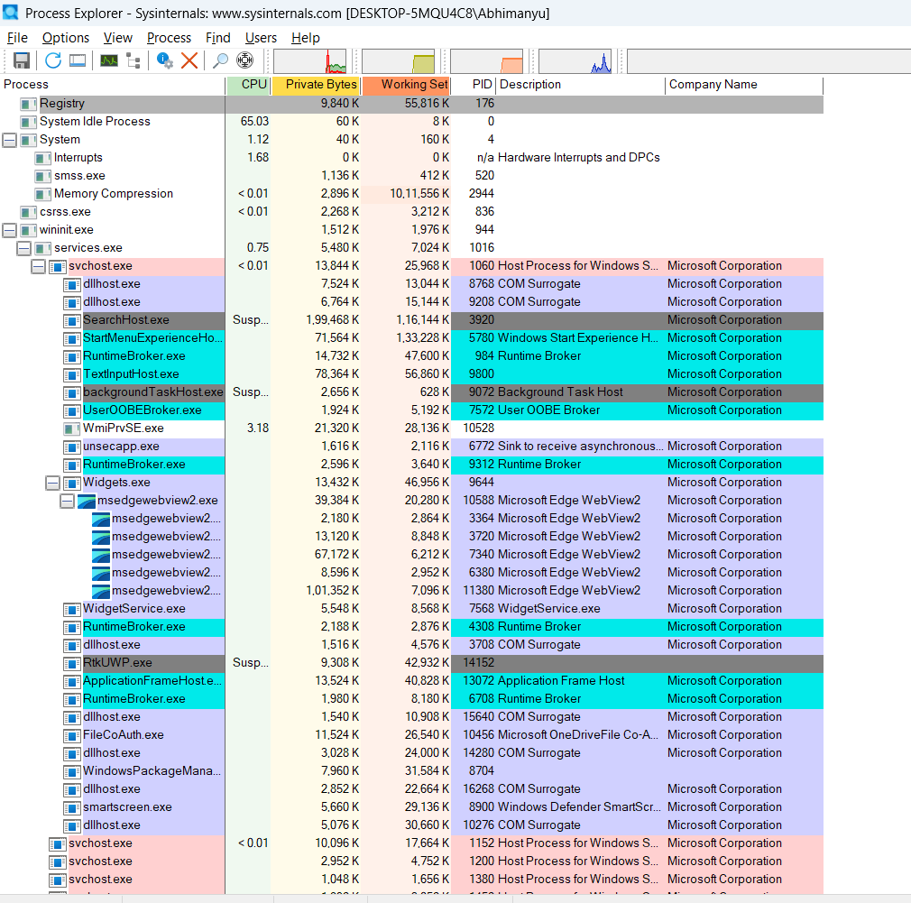

* PROCESS MONITOR

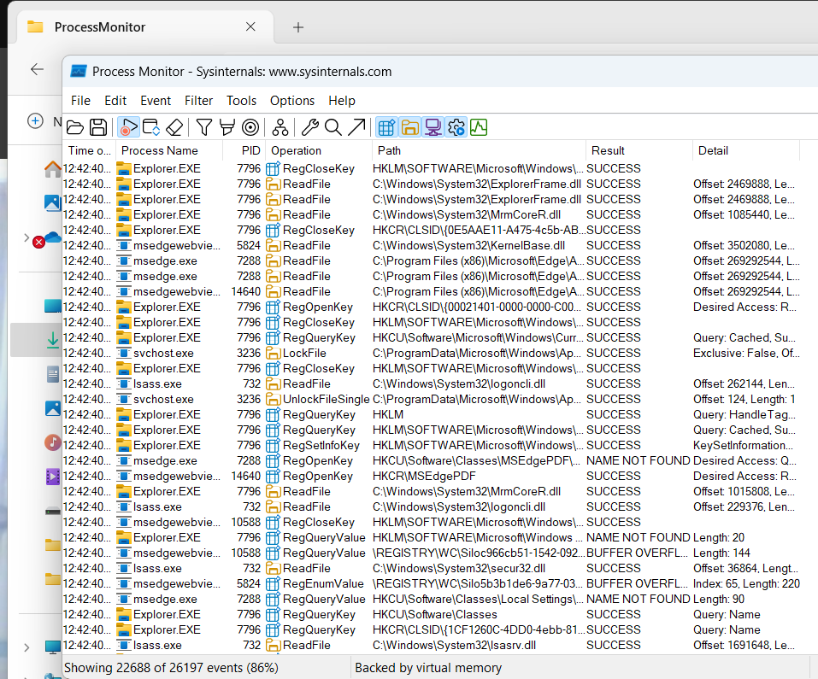

* All PS Tools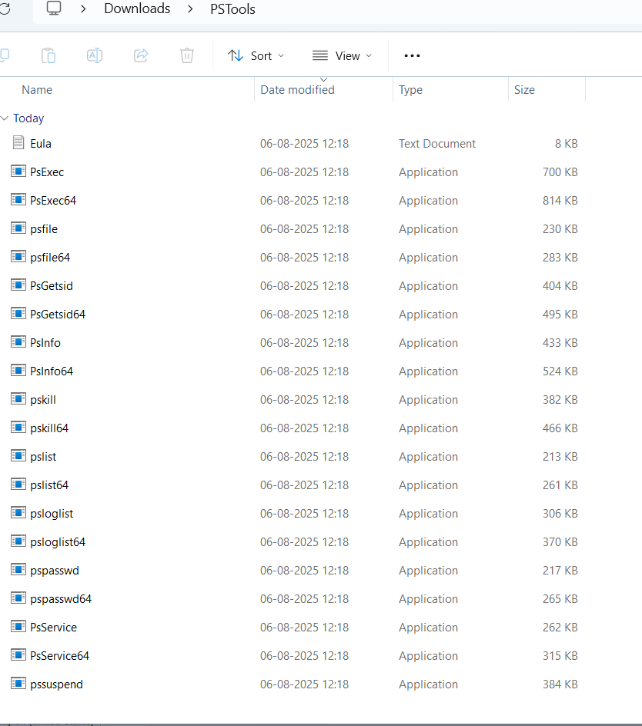

All PS TOOLS

* REG MON

Comes under Process Monitor

WHOIS

